

**PPE Guideline for Sterile Procedures during the COVID 19 Pandemic**

Scope: All sterile procedures within COVID 19(C19) Critical Care including Arterial Line Insertion, Central Line Insertion and Tracheostomy formation

**Prior to entering C19 Critical Care:**

-**Ensure surgical hat is applied prior to entering C19 Critical Care**

-Apply standard C19 PPE including fluid resistant gown, non-sterile gloves, FFP3 and Full Face Visor (consider most light-weight option)

**Pre Procedure**

**-Ensure you are at least 2 metres from the patient’s airway**

-If a sink is close at hand then handwash using *Hibiscrub* in the usual way can be performed (Most SJH Critical Care areas)

-If a 2 metre distanced sink is not readily available near the bed space (RIE/WGH) proceed to **alcohol based hand rub (ABHR)**

**Alcohol based hand rub (ABHR)**

-Prepare trolley (end of bed is usually best) with new sterile gown, sterile gloves and supply of alcohol hand gel

-Remove current non sterile gown and gloves.

**-Keep FFP3 and Full Face Visor on.**

-Perform surgical rub over hands with 70% alcohol based hand rub (or alternative suitable product such as *Sterillium*) using technique as outlined below

-Apply sterile surgical gown from sterile pack then apply sterile surgical gloves

**HPS Best Practice: Surgical rubbing: surgical hand preparation technique using alcohol based hand rub (ABHR) - step by step images**

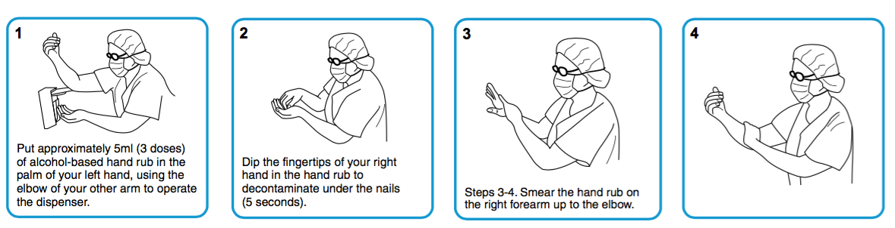

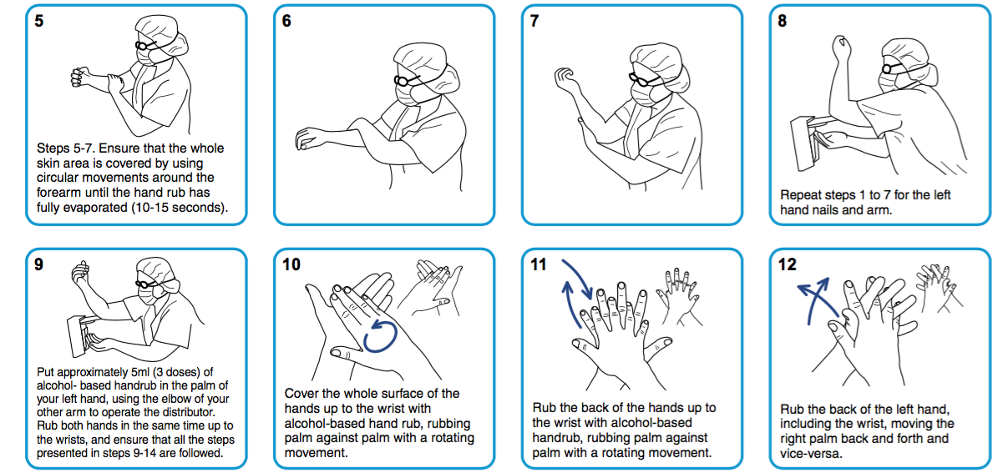

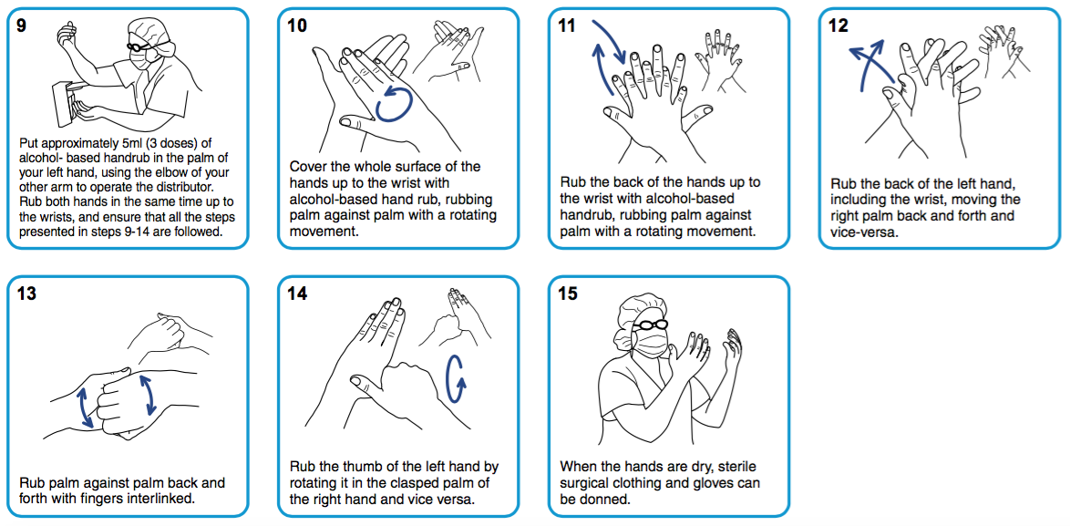

**At end of procedure:**

-Remove sterile gloves and gown at end of bed, ensuring you are at least 2 metres from the patient’s airway

-Perform hand hygiene then re-apply new gown and gloves if required, if remaining in the C19 Critical Care Clinical Area

|  |  |
| --- | --- |
| **Title:**   **PPE Guideline for Sterile Procedures during the COVID 19 Pandemic** | |
|  | **Authors:**  G McNeill M Dunn |
| **Status Draft/Final: FINAL** | **Approved by:** |
|  | **Written:** April 2020 |
| **Reviewed on: Nov 2020** | **Next review : May 2021** |